RESEARCH STUDY - FEBRUARY 2026
AI FOR AMERICANS FIRST
AI Protectionism, Energy and Semiconductors: US/Europe Divergence Trajectories 2024-2030
Integrated Geostrategy and Economic Analysis - CHAPTER VI BIS
76.9% of global operational AI compute = USA | 1.59x EU/US energy cost (PPP-adjusted) | 3.46:1 US/EU CACI ratio (Power Mode)

Fabrice Pizzi
Universite Paris-Sorbonne
Master 2 Intelligence Economique - Intelligence Warfare
Paris - February 2026 | 7 Chapters | 4 Prospective Scenarios | 3 Geographic Zones
Keywords: artificial intelligence, technological protectionism, semiconductors, export controls, sovereign compute, AI geopolitics, France, United States, China
CHAPTER VI BIS
Consequences for South America and Brazil
The analysis of previous chapters has focused on the US-Europe transatlantic axis. However, the consequences of American AI protectionism extend far beyond the OECD. South America, and Brazil in particular, constitute a revealing case study: simultaneously a dynamic market for AI, a terrain of US-China geopolitical competition, and a region structurally dependent on foreign compute while possessing unique energy assets. This complementary chapter analyzes the specific consequences of the protectionist regime on South America, with an in-depth focus on Brazil.
6bis.1 Structural position: the Global South facing compute asymmetry
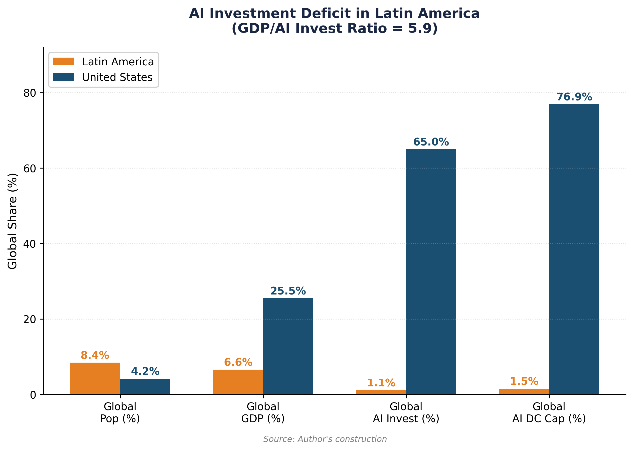

6bis.1.1 A rapidly growing but structurally dependent ecosystem
Latin America represents 6.6 percent of global GDP, but only attracts 1.12 percent of global AI investment—a ratio of 5.9 that measures the region's investment deficit.[1] Yet, adoption indicators are remarkably dynamic. The Latin American Artificial Intelligence Index (ILIA 2025), published by ECLAC and the Chilean CENIA, ranks three countries as pioneers (Chile, Brazil, Uruguay), eight as adopters (including Colombia, Ecuador, Costa Rica), and one-third as explorers with nascent ecosystems.[2] The region represents 14 percent of global visits to AI solutions and ranks third globally for generative AI application downloads.
This adoption dynamic contrasts with a considerable infrastructural deficit. High-income countries host 77 percent of global colocation data center capacity (June 2025), compared to 18 percent for upper-middle-income countries and 5 percent for lower-middle-income countries.[3] High-income countries also concentrate 87 percent of notable AI models, 86 percent of AI startups, and 91 percent of AI venture capital, while representing only 17 percent of the global population. Latin America falls into the intermediate category: a dynamic consumer of AI, but almost entirely dependent on foreign infrastructure (American and, increasingly, Chinese) for compute.
6bis.1.2 Tier 2 classification: compute access caps from the US
Under the January 2025 AI Diffusion Rule (Biden administration), all of Latin America—including Brazil, Mexico, and Chile—is classified as Tier 2, meaning it is subject to quantitative caps on advanced GPU imports. Tier 1 (unlimited access) is reserved for 20 close allies (Australia, Canada, France, Germany, Japan, etc.). Tier 3 (prohibited access) targets China, Russia, and about twenty other countries.[4]
For South America, this Tier 2 classification means that large-scale AI data center projects are capped in terms of importable GPU volume. Initial caps under the AI Diffusion Rule were approximately 50,000 GPUs between 2025 and 2027 for all Tier 2 countries (individually), a volume clearly insufficient to power the announced megaprojects. Brookings observes that even for the most favored Tier 2 countries (Brazil, India), American caps mean that their compute needs will likely not be consistently met.[5] Although the Trump administration rescinded the AI Diffusion Rule in May 2025 without yet publishing a replacement rule, regulatory uncertainty creates a supply risk that weighs on investment decisions. The BIS published America's AI Action Plan in July 2025, which promotes the export of full-stack AI export packages to allies while hardening enforcement toward adversaries.[6]
6bis.2 Brazil: emerging hub between two blocs
6bis.2.1 Brazil's structural assets for AI
Brazil possesses objective competitive advantages for AI infrastructure. Its electricity mix is 83 percent renewable (essentially hydroelectric, supplemented by rapidly growing wind and solar), with a competitive electricity cost of approximately 0.08 USD/kWh. The national interconnected grid (SIN) has surplus capacity, and the country possesses a base of telecommunications submarine cables (notably the Fortaleza hub) offering one of the shortest routes to Europe and Africa.[7]
The Brazilian data center market is the largest in Latin America, representing more than 41 percent of regional investments. Installed IT capacity reached approximately 1 GW by the end of 2025, with 202 active projects and 23 scheduled completions by the end of 2026. The AI data center market specifically is valued at 0.55 billion USD in 2025, projected to reach 1.24 billion by 2030 (annual growth of 17.5 percent).[8] The Brazilian Data Center Association (ABDC) projects that data center energy demand could reach 13.7 GW by 2035.
The Lula government has taken concrete steps to accelerate development. In September 2025, the Redata provisional measure was adopted, creating a special tax regime that reduces the cost of capital for data centers by 50 percent through exemption from taxes on IT assets, with benefits valid until December 2026. The Brazilian Artificial Intelligence Plan (PBIA) aims to transform the country into a global data center hub, and BNDES (National Development Bank) has launched a dedicated AI and data center fund with initial capital of 500 million to 1 billion reais (93-187 million USD).[9]
6bis.2.2 Megaprojects and US-China duality
Brazil has become the theater of direct competition between American and Chinese investments in AI infrastructure, a duality that reveals the dynamics created by US protectionism.
On the Chinese side, the most spectacular project is the TikTok-ByteDance data center in Pecém (Ceará), announced in December 2025: 200 billion reais (approximately 38 billion USD), in partnership with developer Omnia (Pátria Investments) and renewable energy producer Casa dos Ventos.[10] The project, construction of which is to begin in April 2026, will be powered entirely by wind energy (300 MW initially, expandable to 900 MW or even 1 GW). It constitutes the largest private data center investment ever announced in Brazil and ByteDance's first project in Latin America. The investment comes in a context where TikTok faces threats of blocking in the United States and where China seeks to diversify its compute infrastructure outside its direct geopolitical risk zone.
On the American side, Microsoft has announced a 2.7 billion USD investment over three years in cloud and AI infrastructure in Brazil, as part of its 50 billion USD global commitment to the Global South by 2030.[11] AWS and Google already have cloud regions in Brazil (São Paulo). US hyperscalers control approximately 55 percent of the Brazilian cloud market (AWS, Azure, GCP), a smaller dominance than in Europe (70 percent) but enough to structure dependence.
Other megaprojects illustrate the scale of ambitions. Scala Data Centers announced Eldorado do Sul's AI City (Rio Grande do Sul), with 1,800 MW of capacity and a potential for 5,000 MW by 2033. Elea Data Centers is developing Rio AI City, presented as the largest data center campus in Latin America, with 1.8 GW of capacity by 2027 and 3.2 GW by 2032, with Oracle and Nvidia as technology partners.[12]
6bis.3 Impact of US protectionism on South America
6bis.3.1 The double bind of Tier 2 classification
The Tier 2 position of Brazil and South America creates a strategic double bind. On one hand, GPU import caps limit countries' ability to build sovereign AI infrastructure and realize announced megaprojects. On the other, American restrictions toward China (Tier 3) push ByteDance and other Chinese actors to invest heavily in Latin America as an alternative infrastructure deployment zone. Brazil thus becomes a substitution terrain in the US-China rivalry.
Brookings warns that this situation could push Tier 2 countries to develop supply chains independent of the United States, including stronger technological ties with China.[13] Brazil, whose primary trading partner is China, perfectly illustrates this dynamic. The TikTok-Pecém investment, the largest Chinese technological investment in Latin America, is part of a deepening of China-Brazil ties that predated Trump's reelection but accelerated in the face of American trade policies.
6bis.3.2 Five channels of impact
The impact of American AI protectionism on South America is transmitted through five distinct channels, some of which are specific to the region.
Channel 1 - Direct constraint on AI hardware. Tier 2 caps on cutting-edge GPUs limit construction capacity. Even if the AI Diffusion Rule is rescinded, regulatory uncertainty weighs: projects requiring 10,000 to 100,000 GPUs (like Scala AI City or Elea Rio AI City) depend entirely on American willingness to deliver Nvidia or AMD accelerators. The GAIN AI Act, currently under discussion in the US Congress, proposes to give priority access to advanced semiconductors to American consumers before satisfying international orders—which would further degrade the region's supply.[14]
Channel 2 - Reinforced US cloud dependence. In the absence of sufficient local infrastructure, Brazilian companies resort heavily to the US cloud. The Brazilian financial sector (Itaú, Nubank, Bradesco) is the most digitized in Latin America, with 95 percent of transactions processed digitally at Itaú Unibanco. Brazilian Open Banking connects 800 institutions. This digitization relies largely on US hyperscalers, creating the same dependence pattern as for Europe (Chapter IV), but with less bargaining power.
Channel 3 - US-China technological bifurcation. Brazil is faced with a specific risk: the fragmentation of its AI infrastructure between American and Chinese ecosystems. The Pecém data centers (ByteDance), although powered by Brazilian renewable energy, will likely use Huawei hardware or non-US alternatives if American restrictions prevent the export of Nvidia GPUs to Chinese projects. This hardware duality creates issues of interoperability, data sovereignty (US CLOUD Act versus Chinese data security law), and standardization. Brazil risks becoming a space where two incompatible technological ecosystems coexist, fragmented and each dependent on an external power.
Channel 4 - Amplified brain drain. ILIA 2025 signals a widening of the AI talent gap in Latin America since 2022, associated with an acceleration of the brain drain of specialists.[15] Brazil trains excellent engineers (USP, Unicamp, ITA), but the compensation differential with the United States is even more marked than for Europe. Compute asymmetry aggravates this drain: AI researchers who stay in Brazil do not have access to the compute necessary for frontier research, which reinforces the attractiveness of American laboratories.
Channel 5 - Widened productivity gap. The World Bank and the ILO observe that Latin America suffers from a persistent productivity deficit, largely linked to barriers to innovation and technological adoption.[16] If high-income countries capture AI productivity gains (IMF: TFP gains significantly higher in advanced economies), AI protectionism risks transforming what was an adoption delay (temporary buffer) into a structural barrier (bottleneck). Constrained access to cutting-edge compute prevents Latin American companies from realizing the theoretical productivity gains of AI, widening the gap with the United States.
6bis.4 Specific scenarios for Brazil
By applying the 2x2 scenario matrix from Chapter V, the scenarios for Brazil differ from Europe because Brazil has an additional variable: the possibility of playing the Chinese card as an alternative to the US ecosystem. Table 17 details the four possible trajectories.
Scenario A' (Dual Neutral Hub) is the most likely in the short term. Brazil maintains close trade relations with both blocs and has no interest in aligning exclusively. However, this scenario is inherently unstable: the United States could impose conditions (restrictions on the use of Nvidia GPUs in data centers also hosting Chinese workloads), forcing Brazil to choose. Trump's designation of drug cartels as foreign terrorist organizations has already increased the exposure of companies operating in Brazil and Mexico to US export control rules.[17]
Scenario B' (Secondary Sanctions) represents the maximum risk. If the United States decided to apply secondary sanctions against countries hosting significant Chinese AI infrastructure, Brazil would face an existential dilemma: lose access to the American technological ecosystem (Nvidia, AWS, Azure) or renounce massive Chinese investments. This scenario, although unlikely in the short term, is not hypothetical: the United States has already applied secondary sanctions on Russian and Venezuelan oil, and the Affiliates Rule (suspended until November 2026) extends restrictions to subsidiaries of listed entities.[18]
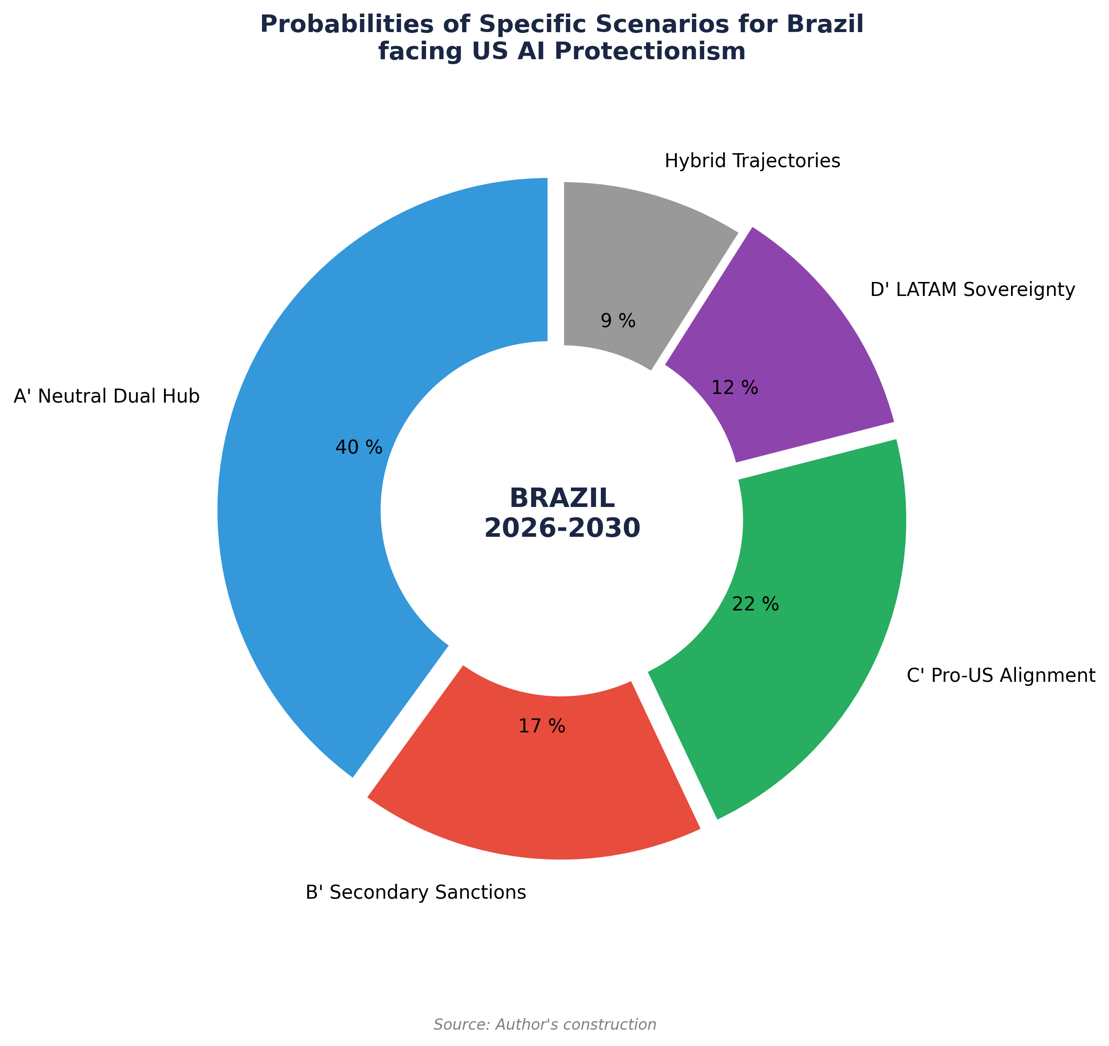

6bis.5 South America beyond Brazil
The other economies of South America undergo the same dynamics as Brazil, but with less bargaining weight and fewer structural assets.
Chile, classified as a pioneer by ILIA 2025, benefits from favorable temperatures (reducing cooling energy consumption) and an advanced AI governance ecosystem. Microsoft launched Chile Central in June 2025, its first cloud region in the country, associated with the Transforma Chile program (180,000 people trained, 81,000 jobs created). But Chile remains entirely dependent on American hardware and cloud, without the Chinese alternative that Brazil has.
Mexico, the United States' immediate neighbor, presents a different profile. Nearshoring (relocating production from Asia) has transformed the economic landscape, and data centers benefit from proximity to the US market. However, Mexico is more vulnerable to American protectionism due to USMCA (renewable in July 2026) and the designation of cartels as terrorist organizations. Its energy infrastructure for data centers is also less competitive than Brazil's.
Colombia, Argentina, and Peru, classified as adopters, face even stronger constraints: fragile electrical infrastructure, limited AI human capital, and near-zero bargaining power with GPU providers. For these countries, American AI protectionism translates primarily into delayed and more expensive access to AI tools, widening the productivity gap not only with the United States but also with Brazil and Chile within the region itself.
6bis.6 Synthesis: a risk of triple fracture
The analysis in this chapter reveals that American AI protectionism produces a risk of triple fracture in South America, specific to the region and distinct from the European scenario.
North-South Fracture. The compute gap between the United States and South America is much more pronounced than the US-Europe gap. While the raw US/EU(13) ratio is 17.6:1 on installed operational compute and the CACI(US)/CACI(EU) ratio is 3.46:1 (Chapter III, April 2026 baseline), an equivalent CACI(US)/CACI(Brazil) ratio would be in the range of 30-50:1 in CACI Power Mode and well over 100:1 in raw compute, reflecting the combination of a deficit in installed computing capacity, more limited AI human capital, and a higher cost of capital (Brazilian Selic at 14.25 percent at the end of 2025). This gap is such that catching up is almost impossible by 2030 without massive external help.
East-West Fracture. The US-China rivalry for AI infrastructure in South America creates a risk of technological fragmentation unparalleled in Europe. Brazil could find itself with two incompatible parallel ecosystems (US cloud versus Chinese infrastructure), each responding to its own geopolitical logic rather than the needs of the local economy. Europe, as a Tier 1 ally, does not face this direct bifurcation on compute, even if the Cloud-Nationality pivot analyzed in Chapter V creates a distinct vulnerability on cloud workloads.
Intra-regional Fracture. Within South America, Brazil attracts most AI investments (41 percent of the LATAM market), followed by Chile and Mexico. 'Explorer' countries (one-third of the region according to ILIA 2025) risk being entirely excluded from the AI economy, reproducing a dependence pattern analogous to that of raw materials. The WEF suggests a regional multi-stakeholder consortium (GAVI model) to pool compute resources and democratize AI access.[19]
For Brazil specifically, the main strategic challenge is to transform its energy assets (83 percent renewable mix) into compute sovereignty, avoiding the US-China competition from fragmenting its ecosystem. The comparison with France is enlightening: both countries possess a distinctive energy asset (nuclear for France, renewable for Brazil), an emerging national technological champion (Mistral for France, fintech/Nubank ecosystem for Brazil), and a regional AI hub ambition. But Brazil faces additional constraints (Tier 2 classification, cost of capital, amplified brain drain) that make its trajectory more uncertain and its vulnerability to protectionism more acute.
Table 16. Major AI data center projects in Brazil (2025-2030).
Source: Author's compilation from Bloomberg, IndustrialInfo, Introl.
Project | Origin | Investment | Capacity | Feature
TikTok Pecém | China | ~38B USD | 300 MW to 1 GW | 100% wind; ByteDance's 1st LATAM project
Scala AI City | Brazil/US | Multi-B USD | 1.8 to 5 GW | Largest planned installation in South America
Elea Rio AI City | Brazil/US | Multi-B USD | 1.8 to 3.2 GW | Oracle + Nvidia technology partners
Microsoft Azure | US | 2.7B USD (3 yrs) | N/A | Cloud + AI + ConectaAI program
AWS São Paulo | US | N/A | Multiple AZ | Active cloud region since 2011

Table 17. Brazil-specific scenarios facing US AI protectionism 2026-2030.
Source: Author's construction, calibration on April 2026 baseline (raw US/EU(13) 17.6:1, CACI Power Mode 3.46:1).
Brazil Scenario | Probability | Positive Consequences | Risks
A': Dual US-China Neutral Hub | 35-45% | Inflow of investments from both blocs; renewable energy as an asset; supplier diversification | Ecosystem fragmentation; US pressure to limit Chinese access; data vulnerability
B': Secondary Sanctions | 15-20% | Acceleration of substitutive Chinese investment | Loss of US ecosystem access (Nvidia, cloud); partial technological isolation
C': Pro-US Alignment | 20-25% | Negotiated Tier 1 access; unlimited GPUs; increased Microsoft/AWS investment | Total US dependence; loss of Chinese investment (Pecém threatened)
D': Regional LATAM Sovereignty | 10-15% | Regional compute consortium; dependence reduction; energy pooling | Limited execution capacity; insufficient capital; 5-10 year delay

Notes
1. ECLAC/CENIA (October 2025), Latin American Artificial Intelligence Index (ILIA 2025). Latin America represents 6.6% of global GDP and 1.12% of global AI investment.
2. ECLAC/CENIA (2025), ibid. Three categories: pioneers (Chile, Brazil, Uruguay, over 60 pts), adopters (Colombia, Ecuador, Costa Rica, Dominican Republic), explorers (nascent ecosystems).
3. World Bank (November 2025), Digital Progress and Trends Report 2025: Strengthening AI Foundations. High-income countries: 77% colocation DC capacity, 87% notable AI models, 86% AI startups, 91% AI VC.
4. BIS (January 2025), Framework for Artificial Intelligence Diffusion. Tier 1: 20 ally countries (unlimited access). Tier 2: ~140 countries including the whole American continent outside US/Canada (quantitative caps). Tier 3: ~20 countries (prohibited access). Rule rescinded in May 2025 by Trump administration, replacement pending.
5. Brookings (2025), 'Trump's AI export controls and the AI Diffusion Rule'. Initial caps: ~50,000 GPUs per Tier 2 country over 2025-2027.
6. BIS (July 2025), America's AI Action Plan. Promoting full-stack AI export packages to allies, hardening toward adversaries.
7. ABDC (2025), Brazilian Data Center Association. Brazilian electricity mix: 83% renewable. Fortaleza hub: submarine cable connections to Europe and Africa.
8. ABDC (2025); Mordor Intelligence (2026). Brazil AI DC market: 0.55B USD (2025) to 1.24B USD (2030), CAGR 17.5%.
9. BNDES (2025); Redata provisional measure (September 2025): 50% reduction in DC capital cost via IT tax exemption, valid until Dec 2026.
10. Bloomberg (December 2025), 'ByteDance Plans 200 Billion-Real Brazilian Data Center'. Partnership Omnia (Pátria Investments) + Casa dos Ventos. 300 MW initial, expandable to 1 GW.
11. Microsoft (2025), 50B USD commitment for Global South by 2030. 2.7B USD specifically for Brazil over 3 years.
12. Scala Data Centers (2025); Elea Data Centers (2025). Rio AI City: Oracle + Nvidia partnership.
13. Brookings (January 2025), op. cit. Tier 2 countries risk developing supply chains independent of US, including reinforced technological ties with China.
14. GAIN AI Act (2025), discussion in US Congress. Priority access to advanced semiconductors for US consumers before international orders.
15. ILIA 2025 (ECLAC/CENIA), AI talent section. Acceleration of specialist brain drain since 2022.
16. World Bank and ILO (2024-2025): persistent productivity deficit in Latin America. IMF (March 2025): AI TFP gains significantly higher in advanced economies.
17. Designation of drug cartels as foreign terrorist organizations (Trump, 2025). Increased exposure of companies operating in Brazil and Mexico to US export control rules.
18. BIS, Suspension of the Affiliates Rule for One Year (November 10, 2025). Affiliates Rule extends restrictions to subsidiaries of listed entities.
19. WEF (2025), regional multi-stakeholder consortium proposal (GAVI model) to pool compute resources in Latin America.

License and Disclaimer. This work, 'AI for Americans First', is made available under the terms of the Creative Commons Attribution-NonCommercial-ShareAlike 4.0 International (CC BY-NC-SA 4.0) license. You are free to share and adapt the material for non-commercial purposes, provided you properly attribute the work to Fabrice Pizzi (Université Paris-Sorbonne) and distribute your contributions under the same license. This document is provided for educational and research purposes only.
Public Dashboard : https://mo0ogly.github.io/America-First-IA/dashboard/
Repository : https://github.com/mo0ogly/America-First-IA
AI for Americans First - Fabrice Pizzi - Chapter VI bis

